AEPHY2024
Narrogin SHS Year 11 ATAR PHYSICS Name:
Task No: | 11
Task Type: | Test
Content: | Waves
Task Description: | Complete the attached questions in the spaces provided.  Marks will be awarded for presentation and working.  Test conditions (60 minutes).  Formulae and data booklet provided.  Non-programmable calculator permitted.
Total Marks: | 44
Weighting: | 6%
Materials required | pens, pencils (including coloured), sharpener, correction fluid, eraser, ruler, highlighters, scientific calculator
Due Date:

Question 1 (3 marks)
Two waves are travelling on a string. The directions and amplitude of each wave is shown in the figure below.

(a) On the line on the right, draw resulting wave when the two waves meet. (1 mark)

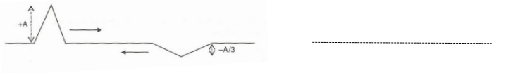

(b) When the two waves meet, calculate the amplitude of the resulting wave. (2 marks)

Question 2 (5 marks)
The diagram below shows two ways in which a wave can travel along a slinky spring.

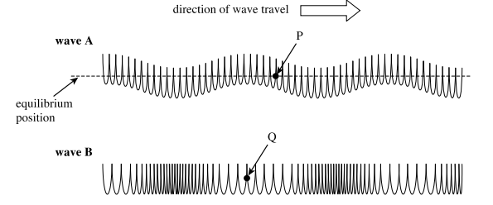

(a) State and explain which wave is longitudinal. (2 marks) ______________________________________________________________________________ ______________________________________________________________________________ ______________________________________________________________________________

(b) On the diagram: (3 marks)
i. clearly indicate and label the wavelength of wave B (between any two points on the diagram)

ii. use arrows to show the direction in which the points P and Q are about to move as each wave moves past these points.

Question 3 (3 marks)
The ear canal acts as a closed column of air 1.70 cm in length from the outer ear to the ear drum. Calculate the fundamental resonant frequency of the ear canal.

Question 4 (3 marks)
You are attend attending a concert night rehearsal and taking sound intensity measurements of Leo playing his saxophone. At the back of the concert hall 21.0 m from Leo you measure an intensity of 1.30 x 10⁻⁶ Wm⁻² . Calculate the distance from Leo where the measurement would be
  - x 10⁻⁵ Wm⁻² .

Question 5 (9 marks)
An instrument maker understands that he can use either a closed or an open pipe to produce a note of the same frequency.

- Calculate the ratio of the length of a closed pipe to an open pipe if they are to produce the same frequency. (3 marks)

The instrument maker manufactures a 2.46 m pipe that can be used to create standing waves in either an open or closed mode by a pedal that opens or closes an aperture at the bottom of the pipe.

- Determine the frequencies of the first three harmonics of the pipe if it is left open at both ends.
(3 marks)

- Determine the frequencies of the first three harmonics of the pipe if it is closed at one end.
(3 marks)

Question 6 (6 marks)

The diagram below shows 6 wave fronts approaching a boundary from water to air. The speed of sound in water is 4.30 times greater than the speed of sound in air.

- Draw four wave-fronts below to show how the path of a sound wave changes as it moves from water to air.
(3 marks)

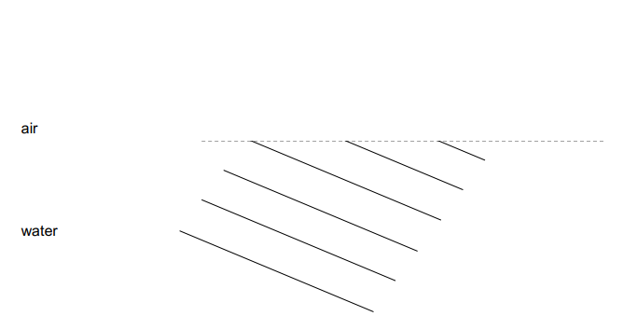

The equation that relates the properties of the wave as it passes through a boundary of different wave speeds is known as Snell’s Law:

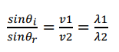

(b) If the wavelength in air is measured to be 0.170 m, calculate the wavelength of the sound wave when it was moving through the water. (3 marks)

Question 7 (7 marks)
A student is playing with a ripple tank that produces uniform linear wave fronts. Barriers can be placed in the path of the wave fronts in order to observe wave phenomena. Complete the two diagrams (drawn to scale) by drawing 4 complete wave fronts as they pass through the barriers.

- (2 marks)
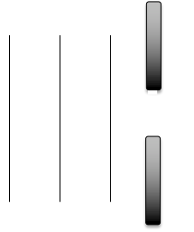

- (2 narks)
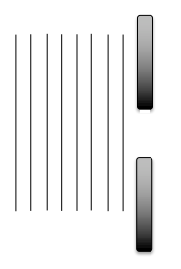

- If the frequency of the source in a) is set to 5.60 Hz, use the diagram to estimate the speed of the
wave fronts. (3 marks)

Question 8 (8 marks)
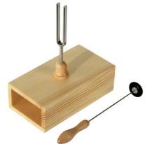
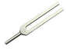
When a tuning fork is struck it oscillates at a set frequency with a low volume. When the tuning fork is connected to a wooden box similar to the one shown in the diagram and then struck, the same frequency is heard at a much louder volume.

(a) Explain this observation (3 marks)

(b) State one other scenario where this phenomenon can be observed. (1 mark)

(c) If the box has a length that corresponds to the first harmonic, calculate the optimum length of the box if the frequency of the tuning fork is 512 Hz and the speed of sound in air is measured to be 338 ms⁻¹
(3 marks)

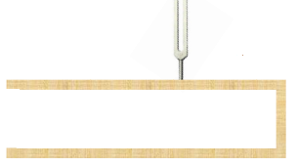
(d) On the diagram, draw in a labelled pressure wave envelope for the first harmonic. (1 mark)

